TOWER DEFENSE

USER DOCUMENTATION

USER MANUAL

Contents

PROLOGUE 1

CONTROL OPERATIONS 1

BEGINNING THE GAME 2

MOVING YOUR CHARACTER 3

TOWERS, CHARACTERS, AND GAME SPECIFICS 3

ENDING THE GAME 5

# PROLOGUE

You have been tasked by your town to keep your town safe from invading monsters! The monsters are invading your colony and if you are not too careful, they might take it over! Your job is to use the resources your town has given you to keep them safe. In order to use these though, you will have to collect money and build extra towers. The towers will be used for the guards. Once you build the towers for the guards, you will more manpower at your disposal to defend your colony and tower. Place your towers where ever you would like, but place them strategically to where they can still be effective in fighting off your monsters. If you fight off all of your monsters, you win the game! If you fail to defend off your monsters, they will invade your tower and take over your colony and lose the game!

# CONTROL OPERATIONS

You will use a keyboard and mouse to control the game.

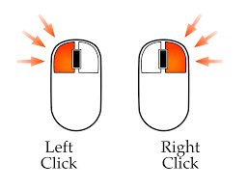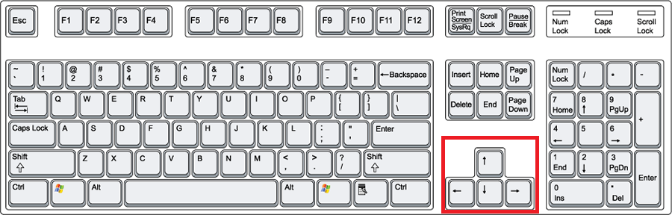

Selecting items in the main menu and building towers

LEFT CLICK BUTTON

You can use the left click button on your mouse to select an option from the menu. Use the left click button within the game to build towers in the location of your choice.

You can use the up, down, left, and right arrows on your keyboard to move your character around the screen. Up will make the character go up the screen, down will make the down the screen, the same goes for right and left.

UP, DOWN, RIGHT, LEFT ARROWS

Moving the character around the screen

# BEGINNING THE GAME

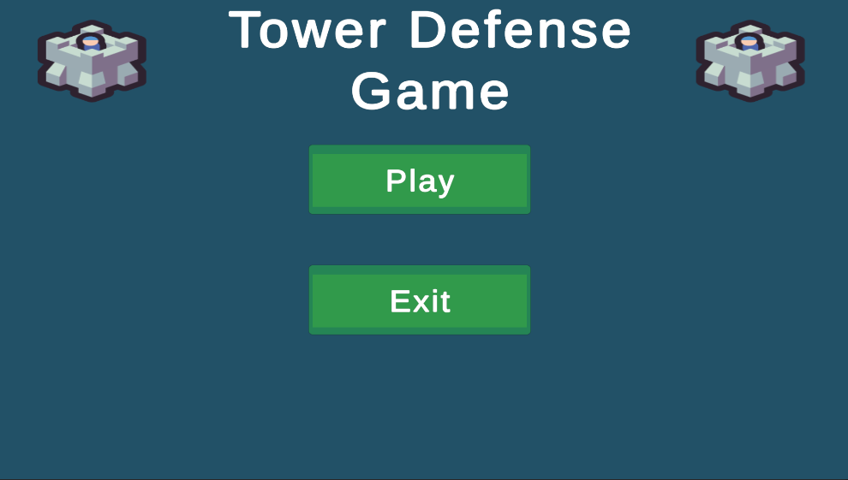

To start the game you will click the “PLAY” button from the main menu screen.

# MOVING YOUR CHARACTER



UP, DOWN, RIGHT, LEFT ARROWS

You can use the up, down, left, and right arrows on your keyboard to move your character around the screen. Up will make the character go up the screen, down will make the down the screen, the same goes for right and left.

Moving the character around the screen

.

# TOWERS, CHARACTERS, AND GAME SPECIFICS

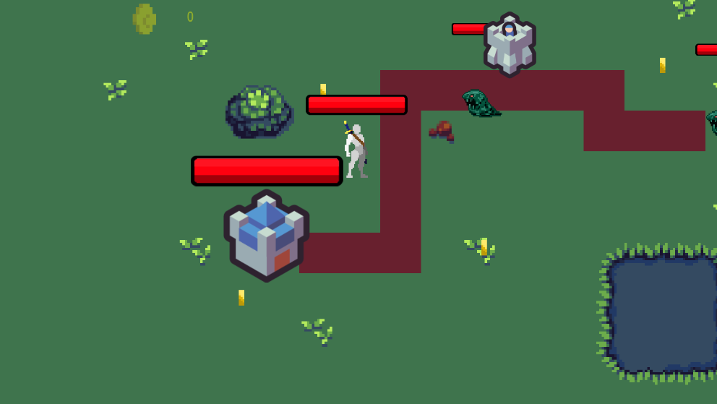

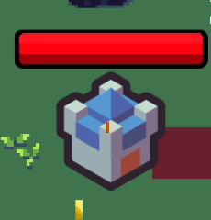

PLAYER DEFENSE TOWER

The player defense tower is the tower you are trying to defend. Beyond these tower doors, is your colony that you must defend! Keep the monsters out of this tower!

MONSTERS

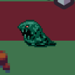

The monsters are invading! You must keep them away from your tower!

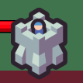

GUARD TOWERS

The guard towers are here to help you! Collect coins to build your towers and defend your colony!

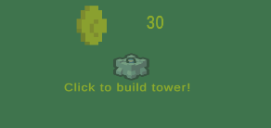

COIN BANK

This is where you will see how much money you have in the bank. Once you get 30 cents in the bank, you can click the bank to build your tower. Click the bank and then click where you want your guard tower to be built.

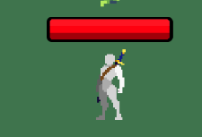

You are the armor of your colony. This is you, it is your responsibility now. Do you have what it takes to save your town?

YOUR AVATAR

Money, Money, Money!! Each coin is worth 10 cents. Collect the coins to build your towers

COINS



# ENDING THE GAME

The game is over once you fight off all of the monsters. If you are unable to fight off the monsters in time, the game is over! Keep playing until you can fight off all of your monsters!